
Second Sunday after Christmas

CHRIST LUTHERAN CHURCH | Lodi, California
January 4, 2026

WELCOME TO WORSHIP
Welcome to Christ Lutheran Church. We pray that your soul will be strengthened by the good news about God’s grace, love, and forgiveness given to us. If you would like to learn more about our church, please speak with our pastor or one of our members after the service.
- Bathrooms are located in the fellowship hall. A changing table is located in the women’s bathroom.
WORSHIP THEME
We continue the Christmas celebration of the dawning of the light of all mankind. When the sun rises, we can see things that we haven’t seen before. When Christ the Savior is born, the light of new revelation breaks over the world. When the Son rises, we can clearly see the grace of God, our Redeemer.

The Service, Setting I
The high and holy worship of God is faith in Jesus Christ. Such faith is created and sustained by God’s service to us (the German, “Gottesdienst,” “The Divine Service”). In the Divine Service, the Lord comes to us in His Word and Sacrament to bless and enliven us with His gifts. The Service is not something we do for God, but His service to us received in faith. The liturgy is God’s work. He gives, we receive.
HYMN Hark! The Herald Angels Sing| CW 350
M: In the name of the Father, and of the Son, and of the Holy Spirit.
C: Amen.

CONFESSION
From God’s Word we know that wherever God puts His name, there He is to bless. In the Old Testament the temple was the place where God graciously caused His name to be present (1 Kings 8:27-30).
God has put His name —Father, Son, and Holy Spirit—on us in Holy Baptism. The Divine Service begins with the Invocation, the words spoken over us at our baptisms. Every Divine Service is for the hallowing of the Lord’s name, which the Small Catechism reminds us is done “when the Word of God is taught in its truth and purity, and we, as the children of God, also lead holy lives according to it” (Matthew 28:18-20).
M: Beloved in the Lord: let us draw near with a true heart and confess our sins to God our Father, asking him in the name of our Lord Jesus Christ to grant us forgiveness.
C: Holy and merciful Father, I confess that I am by nature sinful, and that I have disobeyed you in my thoughts, words, and actions. I have done what is evil and failed to do what is good. For this I deserve your punishment both now and in eternity. But I am truly sorry for my sins, and trusting in my Savior Jesus Christ, I pray: Lord, have mercy on me, a sinner.

absolution
M: God, our heavenly Father, has been merciful to us and has given his only Son to be the atoning sacrifice for our sins. Therefore, as a called servant of Christ and by his authority, I forgive you all your sins in the name of the Father and of the Son ✙ and of the Holy Spirit.
C: Amen

Kyrie
M: In peace let us pray to the Lord.
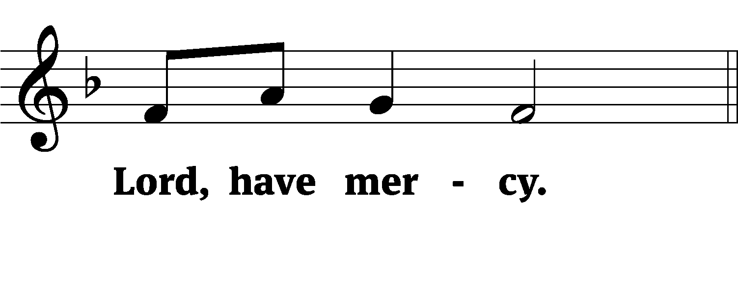
M: For the peace from above and for our salvation, let us pray to the Lord.
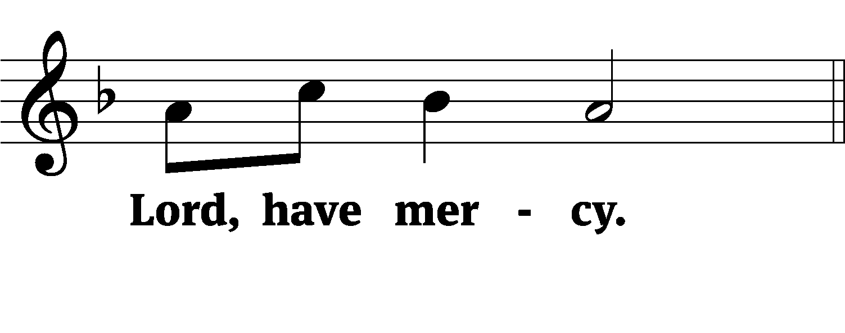
M: For the peace of the whole world, for the well-being of the Church of God, and for the unity of all, let us pray to the Lord.
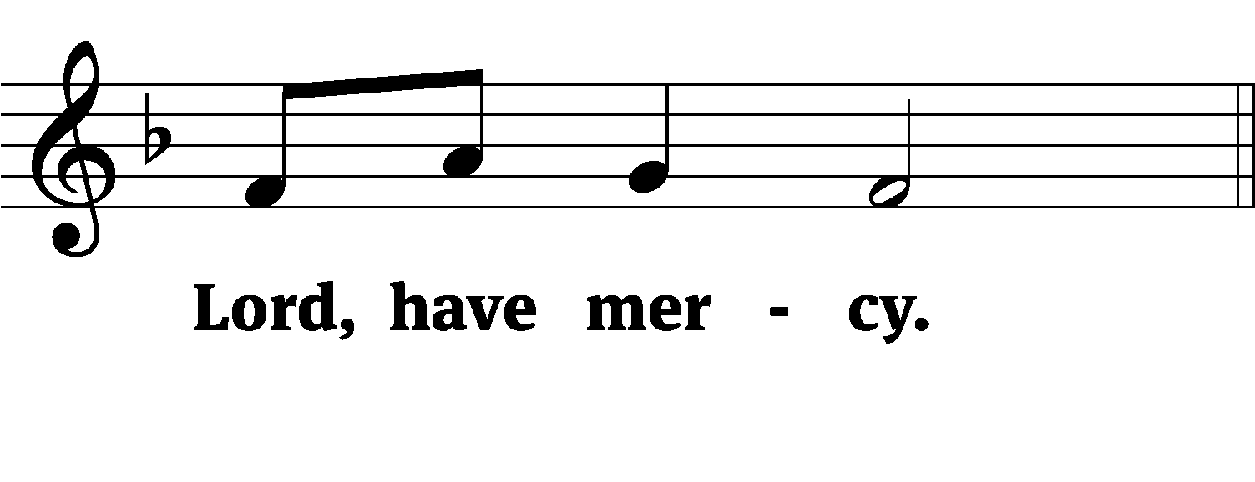
M: For this holy house and for all who offer here their worship and praise, let us pray to the Lord.
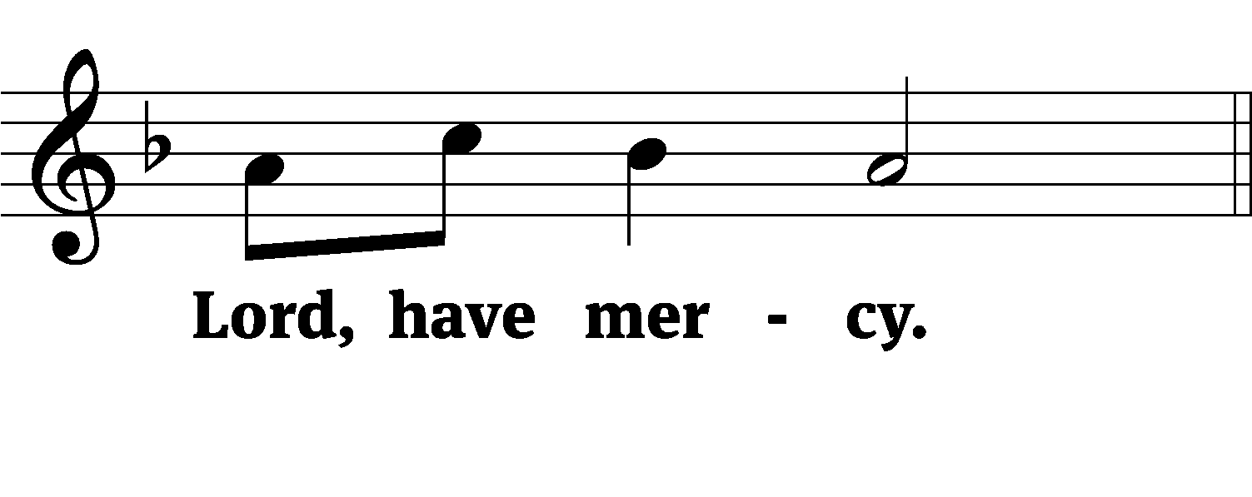
M: Help, save, comfort, and defend us, gracious Lord.
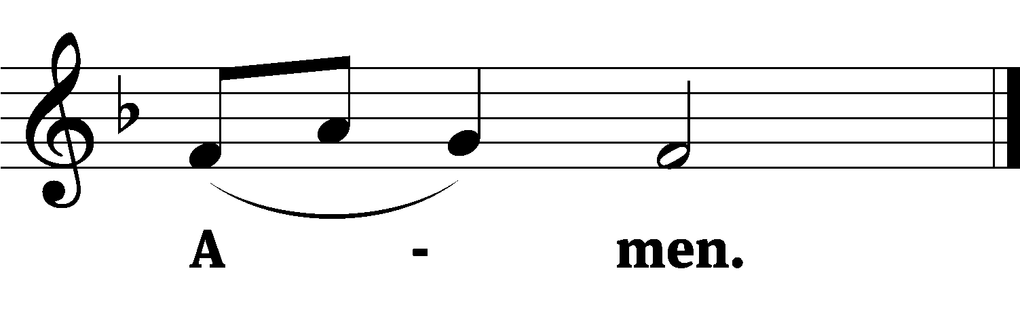
M: Let us praise the Lord.
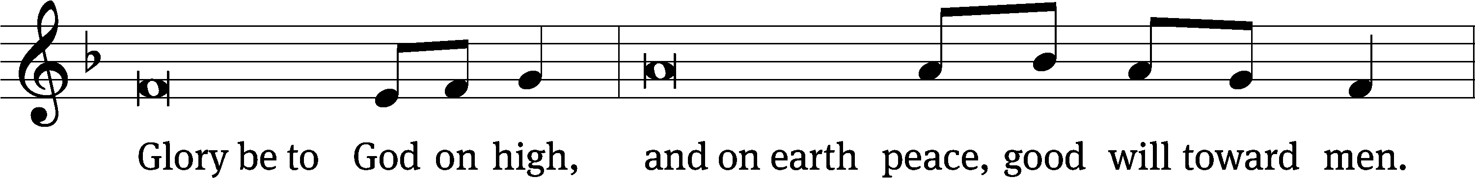
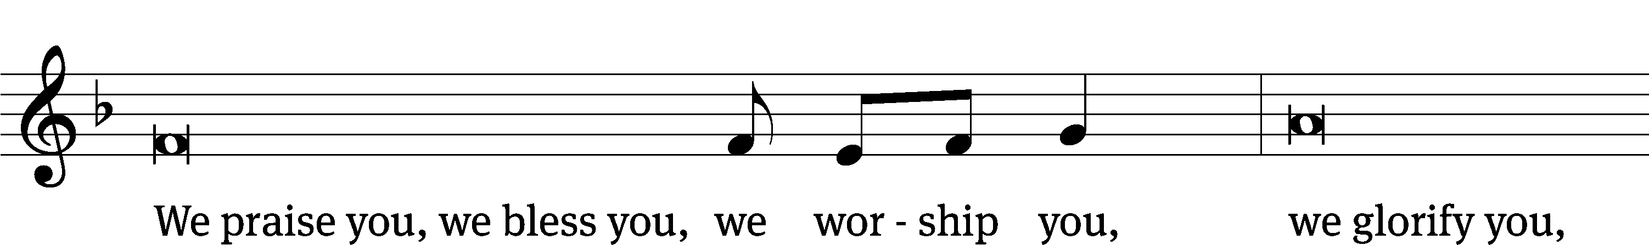
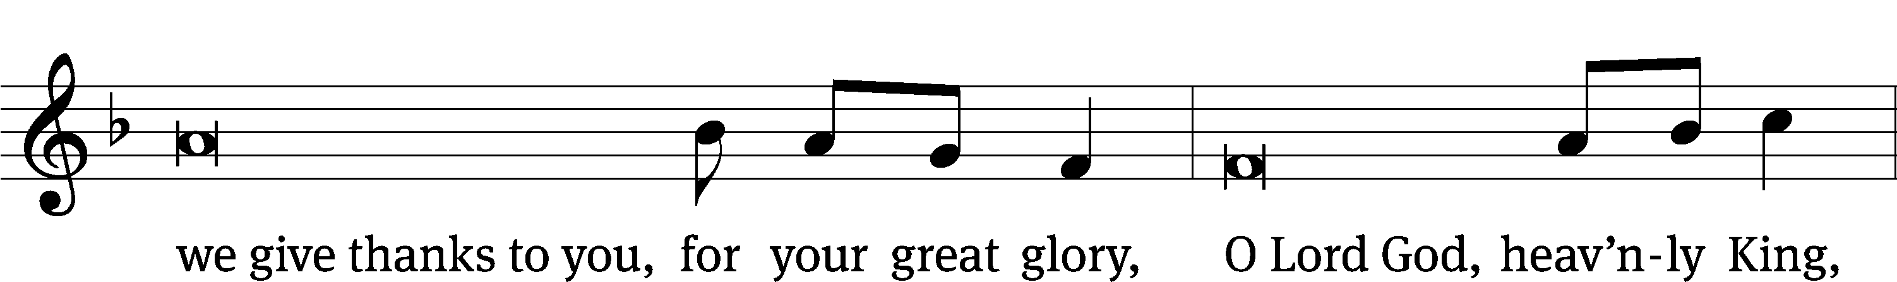
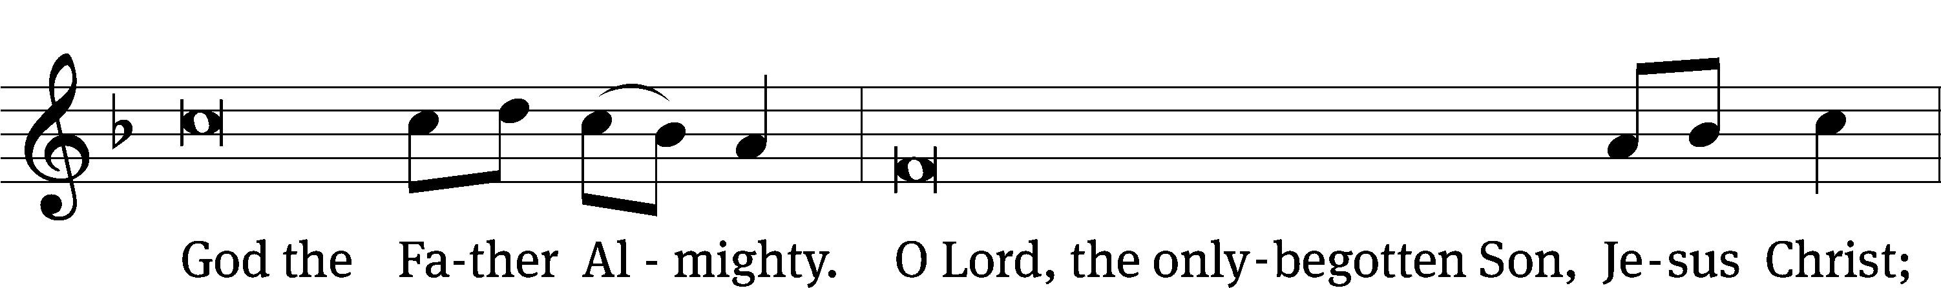
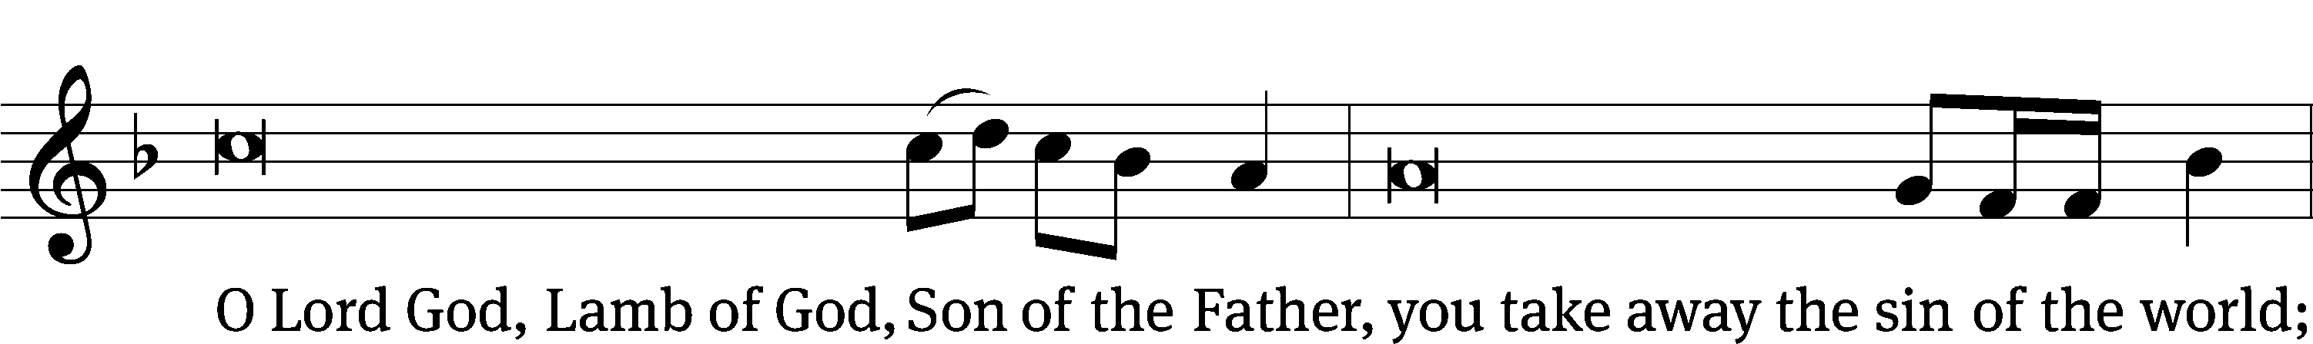
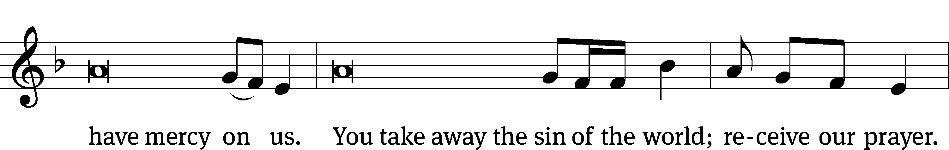
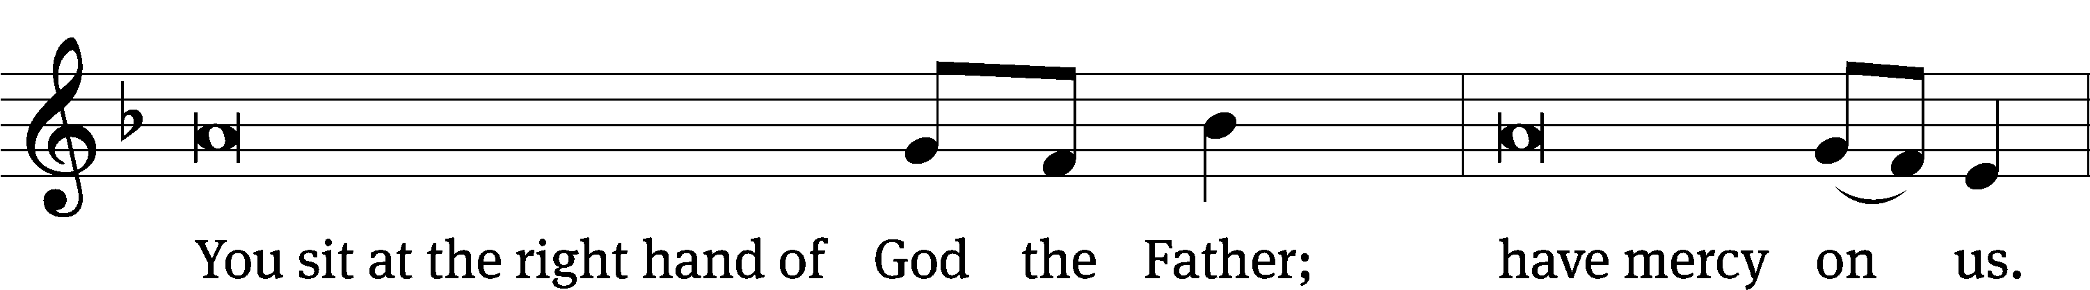
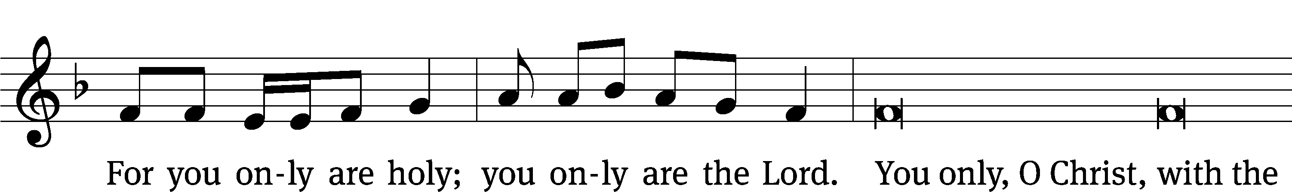
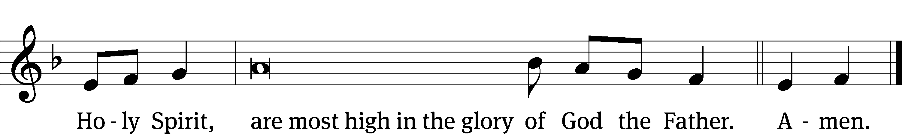
PRAYER OF THE DAY
M: The Lord be with you.
C: And also with you.
M: Let us pray.
Almighty God, you have filled us with the new light of the Word who became flesh and lived among us. Let the light of our faith shine in all we do; through your Son, Jesus Christ our Lord, who lives and reigns with you and the Holy Spirit, one God, now and forever.
C: Amen
FIRST LESSON Isaiah 61:10—62:3
The Lord bestows his glory upon his people.
I delight greatly in the Lord;
my soul rejoices in my God.
For he has clothed me with garments of salvation
and arrayed me in a robe of his righteousness,
as a bridegroom adorns his head like a priest,
and as a bride adorns herself with her jewels.
For as the soil makes the sprout come up
and a garden causes seeds to grow,
so the Sovereign Lord will make righteousness
and praise spring up before all nations.
For Zion’s sake I will not keep silent,
for Jerusalem’s sake I will not remain quiet,
till her vindication shines out like the dawn,
her salvation like a blazing torch.
The nations will see your vindication,
and all kings your glory;
you will be called by a new name
that the mouth of the Lord will bestow.
You will be a crown of splendor in the Lord’s hand,
a royal diadem in the hand of your God.
PSALM Psalm 148
SECOND LESSON Ephesians 1:3–18
Our glorious inheritance was promised before creation and fulfilled in Christ.
Praise be to the God and Father of our Lord Jesus Christ, who has blessed us in the heavenly realms with every spiritual blessing in Christ. For he chose us in him before the creation of the world to be holy and blameless in his sight. In love he predestined us for adoption to sonship through Jesus Christ, in accordance with his pleasure and will— to the praise of his glorious grace, which he has freely given us in the One he loves. In him we have redemption through his blood, the forgiveness of sins, in accordance with the riches of God’s grace that he lavished on us. With all wisdom and understanding, he made known to us the mystery of his will according to his good pleasure, which he purposed in Christ, to be put into effect when the times reach their fulfillment—to bring unity to all things in heaven and on earth under Christ.

In him we were also chosen, having been predestined according to the plan of him who works out everything in conformity with the purpose of his will, in order that we, who were the first to put our hope in Christ, might be for the praise of his glory. And you also were included in Christ when you heard the message of truth, the gospel of your salvation. When you believed, you were marked in him with a seal, the promised Holy Spirit, who is a deposit guaranteeing our inheritance until the redemption of those who are God’s possession—to the praise of his glory.
For this reason, ever since I heard about your faith in the Lord Jesus and your love for all God’s people, I have not stopped giving thanks for you, remembering you in my prayers. I keep asking that the God of our Lord Jesus Christ, the glorious Father, may give you the Spirit of wisdom and revelation, so that you may know him better. I pray that the eyes of your heart may be enlightened in order that you may know the hope to which he has called you, the riches of his glorious inheritance in his holy people.
VERSE OF THE DAY Psalm 98:3
Alleluia. All the ends of the earth have seen the salvation of our God. Alleluia.
THE GOSPEL John 1:14–18
Christ makes it possible for us to behold the glory of God in the flesh.
The Word became flesh and made his dwelling among us. We have seen his glory, the glory of the one and only Son, who came from the Father, full of grace and truth.
(John testified concerning him. He cried out, saying, “This is the one I spoke about when I said, ‘He who comes after me has surpassed me because he was before me.’”) Out of his fullness we have all received grace in place of grace already given. For the law was given through Moses; grace and truth came through Jesus Christ. No one has ever seen God, but the one and only Son, who is himself God and is in closest relationship with the Father, has made him known.
M This is the Gospel of the Lord.
C: Praise be to you, O Christ!

NICENE CREED
We believe in one God, Dt. 6:4
the Father, the Almighty, 2 Cor. 6:18
maker of heaven and earth, Is. 51:13
The Nicene Creed is the great Confession of the Christian faith professed by all Christians. The Creed originated at the First Council of Nicaea (c. AD. 325)
of all that is, seen and unseen. Col. 1:16
We believe in one Lord, Jesus Christ, 1 Cor 8:6
the only Son of God, Jn. 3:16
eternally begotten of the Father, Heb. 1:2,5
God from God, Light from Light, true God from true God, Jn. 1
begotten, not made, of one being with the Father. Jn. 10:30
Through him all things were made. Jn. 1:3
For us and for our salvation, 1 Th. 5:9
he came down from heaven, Jn. 6:38
was incarnate of the Holy Spirit and the virgin Mary, Lk. 1:35
and became fully human. Gal. 4:4
For our sake he was crucified under Pontius Pilate. Mk. 15:15
He suffered death and was buried. 1 Cor. 15:3-4a
The Creed itself was crafted as a confession of Scripture in opposition to the Arian heresy, which denied that the Lord Jesus and the Holy Spirit are God.

On the third day he rose again in accordance
with the Scriptures. 1 Cor. 15:4b
He ascended into heaven Ac. 2:33-34
and is seated at the right hand of the Father. Heb. 1:13
He will come again in glory Mt. 25:31
to judge the living and the dead, 2 Tim. 4:1
and his kingdom will have no end. Lk. 1:33
We believe in the Holy Spirit, the Lord, the giver of life, Job 33:4
who proceeds from the Father and the Son, Jn. 15:26
who in unity with the Father and the Son Jn. 4:24
is worshiped and glorified,
who has spoken through the prophets. 2 Pet. 1:25
We believe in one holy Christian Mt. 16:18; Eph. 2:19-20
and apostolic Church.
We acknowledge one baptism for the forgiveness of sins. Eph. 4:5; Ac. 2:38
We look for the resurrection of the dead 1 Cor. 15:21-22
and the life of the world to come. Amen. Rev. 22
HYMN OF THE DAY The Only Son From Heaven| CW 383
SERMON Isaiah 61–62
OFFERTORY
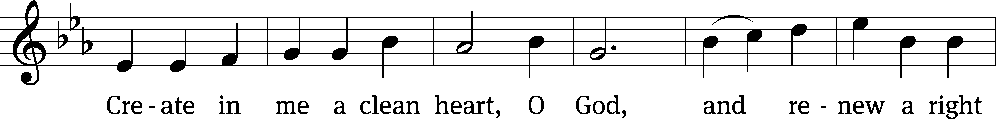
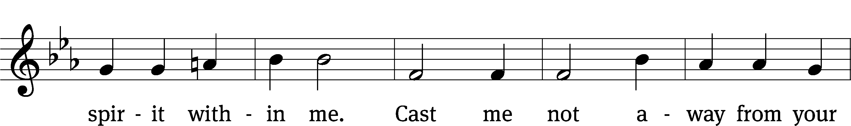
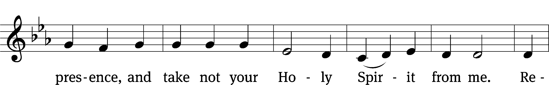
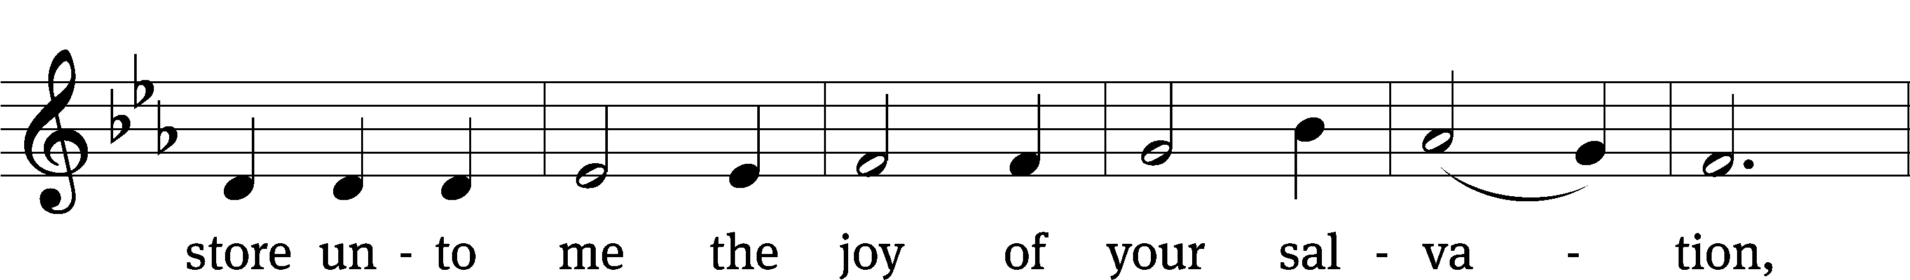
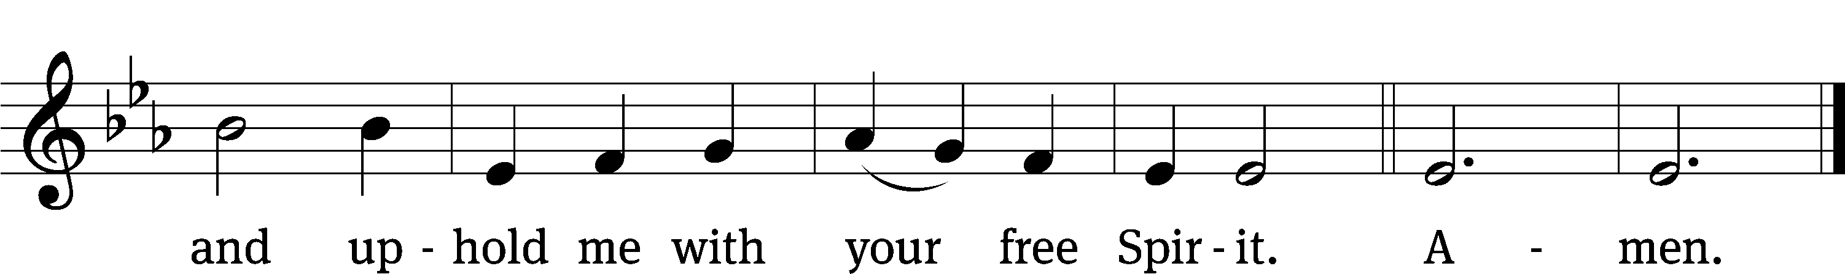
OFFERING
In response to God’s love and forgiveness, we give back a portion of what he has given us. The members of Christ Lutheran Church have joined to proclaim the gospel to this community. These offerings support that work. While our guests are welcome to participate, they should not feel obligated to do so.
PRAYER OF THE CHURCH
The Great O Antiphons of Advent have been cherished for centuries by Christian worshipers. Each one consists of a title given to Christ in the Old Testament and a petition asking him to come and fulfill the Scriptural promise or prophecy. It has been adapted into the familiar hymn O Come, O Come, Emmanuel.
M: Sovereign Lord, you have bestowed on us the glorious crown of your righteousness. In confidence we come before you, trusting that your ear is lovingly attentive to our prayers and your heart inclined to answer for our good. Keep us steadfast in this trust and let us always adorn ourselves with the garments of your Son’s salvation. Lord, in Your mercy,
C: Hear our prayer.
M: Heavenly Father, You have blessed us in Christ, Your beloved Son, in whom we have redemption through His blood, the forgiveness of sins. Preserve Your Church by the preaching of the Gospel of salvation and the seal of the promised Holy Spirit in Baptism. Raise up among us faithful preachers to the praise of Christ’s glory, until we acquire the inheritance promised us in Him. Lord, in Your mercy,
C: Hear our prayer.
M: Almighty God, Your own Son became incarnate for us and grew from childhood into maturity filled with wisdom, and Your favor was upon Him. Grant to parents and children the wisdom and courage to know You as Savior and Redeemer and to gather at Your bidding around Your Word and table. Help us form within our children the knowledge of what is right and good according to Your Word, as well as the will to do it. Lord, in Your mercy,
C: Hear our prayer.
M: Gracious Lord, You set apart kings and governments to safeguard Your people. Bless, we pray, our president; the Congress; our governor; our legislature; and all those who make, administer and judge our laws. Make them wise, and give them a discerning heart in the pursuit of justice for the offender, peace between the nations, and protection for the unborn and those least able to defend themselves. Lord, in Your mercy,
C: Hear our prayer.
M: Merciful God, give patience and endurance to all who are sick or in any need, [especially _____________,] and heal them according to Your will. Give comfort and hope to all who mourn [especially _____________]. Receive our thanksgiving for every blessing and kindness You have shown to Your people in Christ. Lord, in Your mercy,
C: Hear our prayer.
M: O Lord, as blessed Mary treasured all things in her heart, grant us to know what is worthy of our attention and what will pass away, that approaching the table of our Lord we may be well-prepared to receive with repentance and faith His flesh for the life of the world and His blood that cleanses us from all our sin. Lord, in Your mercy,
C: Hear our prayer.
M: All these things and whatever else You know that we need, grant us, Father, for the sake of Him who died and rose again and now lives and reigns with You and the Holy Spirit, one God forever.
C: Amen.
LORD’S PRAYER Matthew 6:9-13; Luke 11:2-4
C: Our Father who art in heaven,
hallowed be thy name,
thy kingdom come,
thy will be done on earth as it is in heaven.
Give us this day our daily bread;
and forgive us our trespasses,
as we forgive those
who trespass against us;
and lead us not into temptation,
but deliver us from evil.
For thine is the kingdom, and the power,
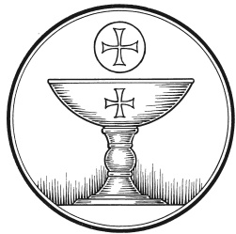
and the glory forever and ever. Amen.

The Service of the Sacrament
This greeting marks a new service, so to speak. These ancient introductory words & phrases help to highlight, celebrate and bring attention to the Sacrament.
M: The Lord be with you.
C: And also with you.
M: Lift up your hearts.
C: We lift them up to the Lord.

M: Let us give thanks to the Lord our God.
C: It is good and right so to do.
M: It is truly good and right that we should at all times and in all places give you thanks, O Lord, holy Father, almighty and everlasting God, through Jesus Christ, our Lord, by whose wonderful and mysterious birth you have opened our eyes to the glory of your grace and renewed in our hearts the fervor of your love. Therefore with all the saints on earth and hosts of heaven, we praise your holy name and join their glorious song:
HOLY, HOLY, HOLY – Sanctus
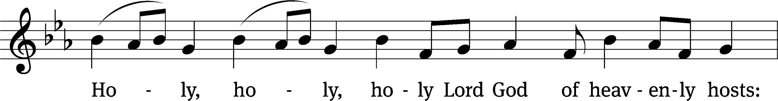
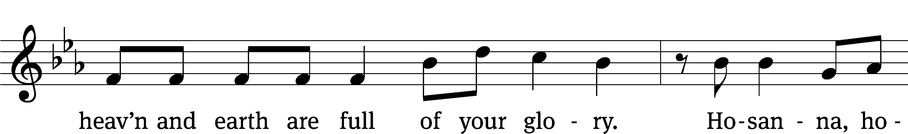
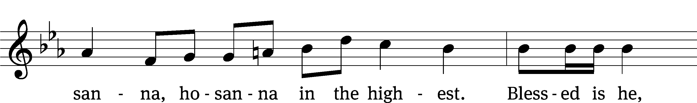
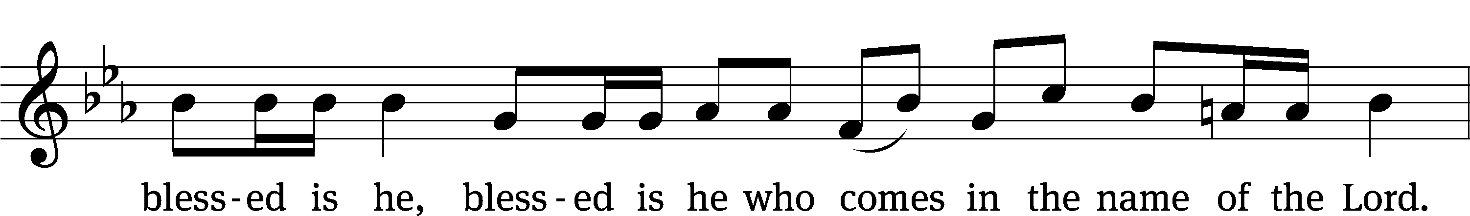
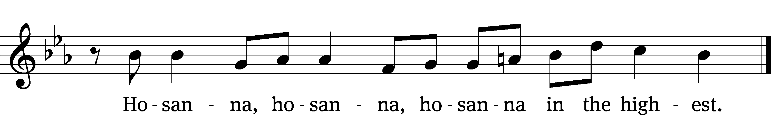

WORDS OF INSTITUTION Matthew 26, Mark 14, Luke 22
M: Our Lord Jesus Christ, on the night he was betrayed, took bread; and when he had given thanks, he broke it and gave it to his disciples, saying: “Take and eat. This is my ✙ body, which is given for you. Do this in remembrance of me.”
The Words of institution both proclaim the words of Jesus to the congregation and sets apart the bread and wine for the Lord’s Supper.
Then he took the cup, gave thanks, and gave it to them, saying, “Drink from it all of you; this is my ✙ blood of the new covenant, which is poured out for you for the forgiveness of sins. Do this, whenever you drink it, in remembrance of me.”

PEACE OF THE LORD – Pax Domini John 20:19
M: The peace of the Lord be with you always.
C: Amen

O CHRIST, LAMB OF GOD – Agnus Dei John 1:29
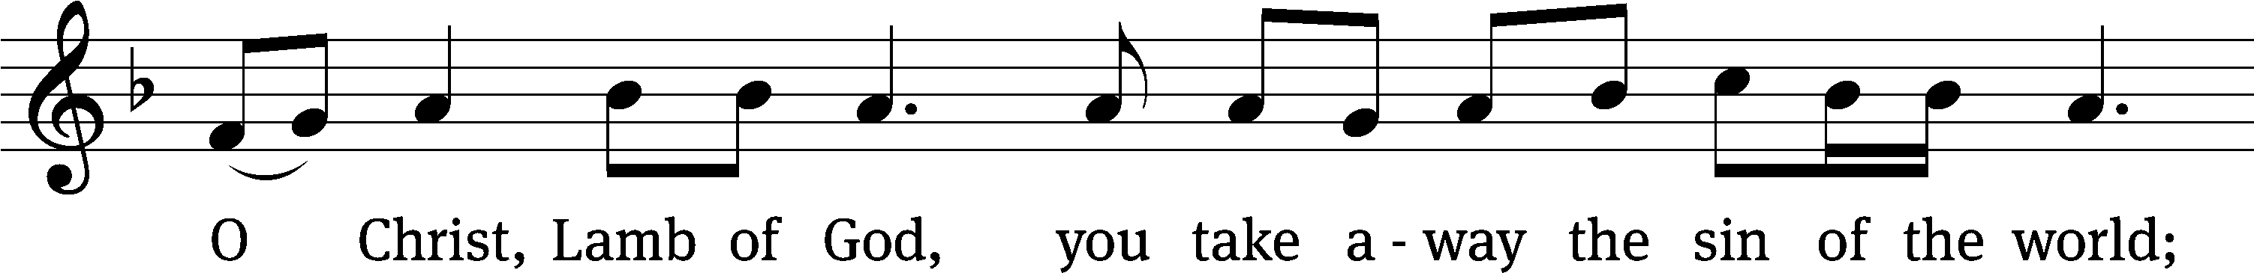
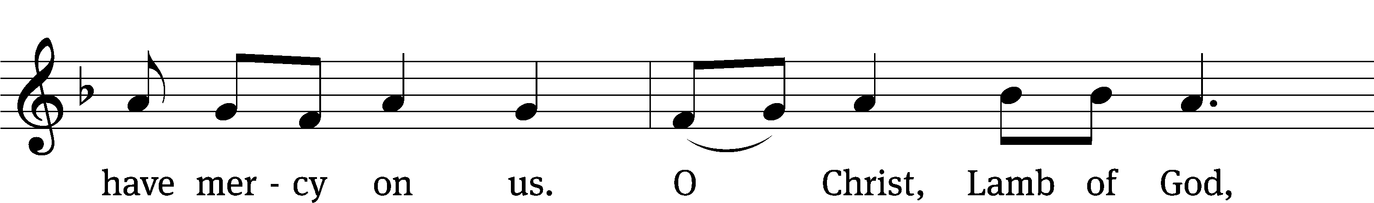
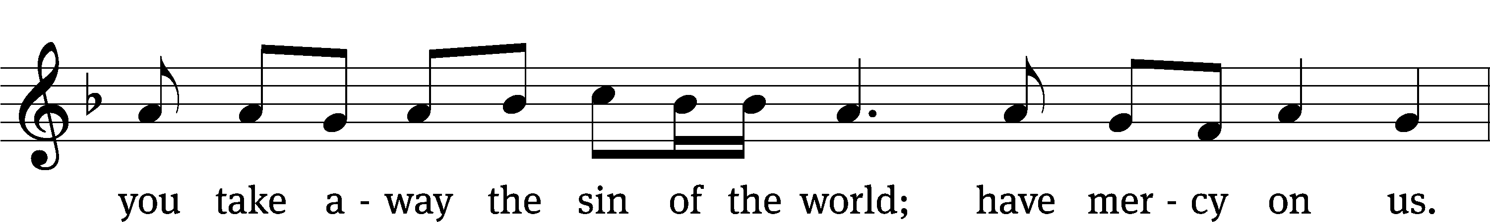
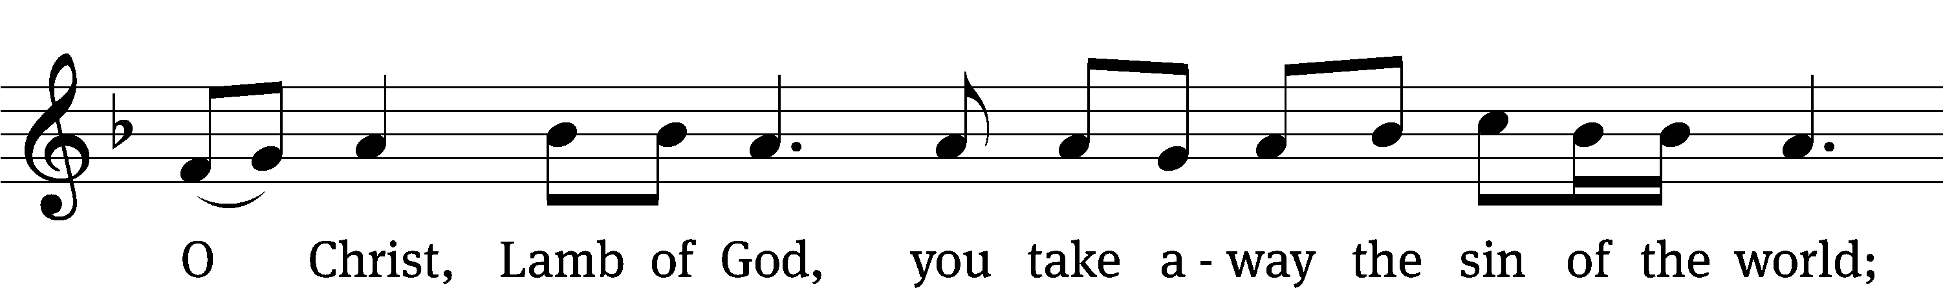
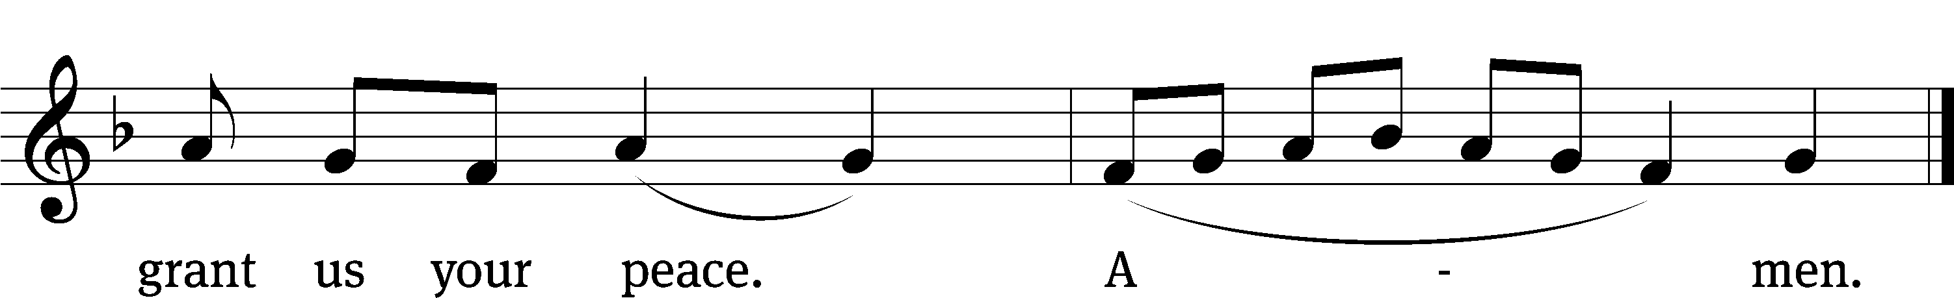

DISTRIBUTION
Those who will be receiving Holy Communion today may wish to read Personal Preparation for Holy Communion, found on page 295 in the front section of the hymnal. This page helps us put into practice what the Bible encourages: “Everyone ought to examine themselves before they eat of the bread and drink from the cup.” (1 Corinthians 11:28)
Christ Lutheran Church confesses and practices the Biblical teaching of a Closed Communion. We ask that only members of the Wisconsin Synod [WELS] or the Evangelical Lutheran Synod [ELS] join us at the Lord’s Table. If you have questions concerning our communion practice, or would like to inquire about how you, too, can commune with us, please speak with the Pastor following the service.
During the Distribution, the congregation may join to sing Hymn 354: O Come, All Ye Faithful before or after they receive the Sacrament.

THE SONG OF SIMEON
C:  Lord, now you let your servant, depart in peace
According to your word.
For my eyes have seen your salvation,
Which you have prepared before the face of all people,
A light to lighten the Gentiles
And the glory of your people Israel.
M: We give thanks, almighty God, that you have refreshed us with this holy supper. We pray that through it you will strengthen our faith in you and increase our love for one another. We ask this in the name of Jesus Christ, our Lord, who lives and reigns with you and the Holy Spirit, one God, now and forever.
C: Amen.

THE BLESSING
M: The Lord bless you and keep you.
The Lord make his face shine on you and be gracious to you.
The Lord look on you with favor and ✙ give you peace.
C: Amen.
CLOSING HYMN Dawning Light of Our Salvation| CW 311

COPYRIGHT INFORMATION
Content requiring a copyright license is reproduced under OneLicense.net #A-718312. All rights reserved. The Common Service: Texts revised from The Lutheran Hymnal, 1941. Music revised by James Engel. Scripture Quotations: From the Holy Bible, New International Version (NIV 1984), © 1973, 1978, 1984 by Biblica, Inc.

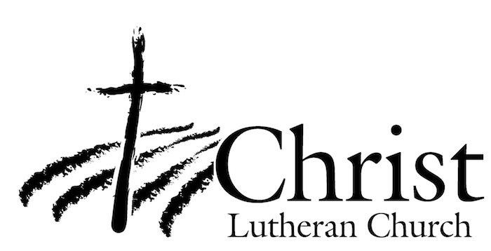
13009 N. Elderberry Ct.
Lodi, CA 95242
www.christlodi.org
209-368-6250
Pastor Timothy Leistekow
WELCOME TO CHRIST EV. LUTHERAN CHURCH!
We preach a message of forgiveness, hope and peace
through the death and resurrection of Jesus Christ.
Families and individuals of all ages will find opportunities
both to grow and to serve.
Our mission statement:
Look what Christ is doing!
He binds us together in fellowship
He gathers us in for worship
He builds us up for service
He sends us out with the gospel

“Now you are the body of Christ,
and each one of you is a part of it.”
(1 Corinthians 12:27)

